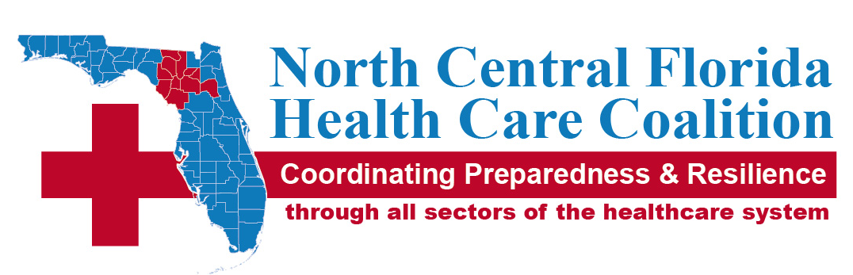
Meeting Summary |  |  | SEPTEMBER 19, 2016 |  | fACE-TO fACE Alachua County Eoc
Meeting called by |  | Coalition vote
Type of meeting |  | Regular Quarterly
Facilitator |  | Coalition Chair, Harold Theus
Note taker |  | Kendra Siler-Marsiglio, PhD
Attendees  CHD=County Health Department  EM=Emergency Management  EMS=Emergency Medical Services |  | Board Member/Designee Attended: Harold Theus-Alachua County EMS, Paul Myers-Alachua CHD Administrator, Mary Garcia-Putnam CHD Administrator, Lola Butler-Dixie CHD Representative, Rel Perea-Hamilton CHD Representative, Kavin Catalfu-Columbia CHD Representative, Suzanne DeKay-UF Health-Shands, Kendra Siler-Marsiglio-WellFlorida, Jen Horner-Alachua Co. EM, Mark Johnson-DOH- Levy, Paul Hamilton-NFRMC, David Hartzell-Lake Butler Hospital  Guests - Sandi Courson-Region 3 Regional Emergency Response Advisor, Sam MacDonell-Region 2 Regional Emergency Response Advisor, Don Barnes-Center for Independent Living of North Central Florida, Shawn Hall-North East Florida Fusion Center
1:30PM |  |  | welcome
Discussion | Welcome and start of meeting
 |  |  | Old Business
Discussion | Approve Minutes from June 13, 2016 meeting
Conclusion | Meeting minutes were motioned for approval by David Hartzell and seconded by Mary Garcia. Motion passed unanimously. All voting blocks were represented at the meeting. Motion was approved unanimously.
Discussion | Finalize NCFHCC:STAR MOA approved at last meeting.
Conclusion | MOA signed by NCFHCC was co-signed by STAR.
NEW BUSINESS

DISCUSSION | NCFHCC:WellFlorida agreement presented by Chief Theus
CONCLUSION | Voting blocks voted on signing NCFHCC:WellFlorida agreement. Vote was motioned for approval by David Hartzell and seconded by Suzanne DeKay. All voting blocks were represented at the meeting. Motion was approved unanimously. A change from last year’s agreement: WellFlorida will be performing fiscal duties for NCFHCC instead of the Alachua County DOH.
DISCUSSION | Voting on new Vice Chair nominee Dan Mann presented by Chief Theus
CONCLUSION | Voting blocks voted on Dan Mann as the new NCFHCC Vice Chair. Vote was motioned for approval by David Hartzell and seconded by Rel Perea. All voting blocks were represented at the meeting. Motion was approved unanimously
DISCUSSION | Administrative Plan & Bylaws presented by Chief Theus & Kendra Siler-Marsiglio
CONCLUSION | Voting blocks voted on changes to the NCFHCC Bylaws. Vote to accept all changes with adjustments as discussed was motioned for approval by David Hartzell and seconded by Lola Butler. All voting blocks were represented at the meeting. Motion was approved unanimously. Updated Bylaws will be provided to members; Administrative Plan will be updated with new Bylaw changes. Suzanne DeKay-UF Health-Shands was also nominated for Secretary/Treasurer.
DISCUSSION | NCFHCC Work Plan presented by Chief Theus & Kendra Siler-Marsiglio
CONCLUSION | Standard applications for NCFHCC funded projects will be presented at Dec 2016 meeting. Each voting block is to select one member of the voting block to represent the block on the new board. Once Board is selected, Board will meet monthly.
DISCUSSION | North East Florida Fusion Center presented by Shawn Hall
CONCLUSION | Information Only. Region 3 has the North East Florida Fusion Center that works with the Florida Fusion Center in Tallahassee.

ANNOUCEMENTS

DISCUSSION | Don Barnes, Center for Independent Living of North Central Florida
CONCLUSION | Information Only. Open House will be held on Fri Oct 21 from 4-7pm. Please join us! For more information visit cilncf.org.

ADJOURNMENT

DISCUSSION | Next Meeting
CONCLUSION | The next meeting will be held on Dec 5, 2016 at 1330 at the Alachua County Emergency Operations Center. The meeting is to be a Holiday Party hosted by WellFlorida. The meeting was adjourned at 3:05PM

